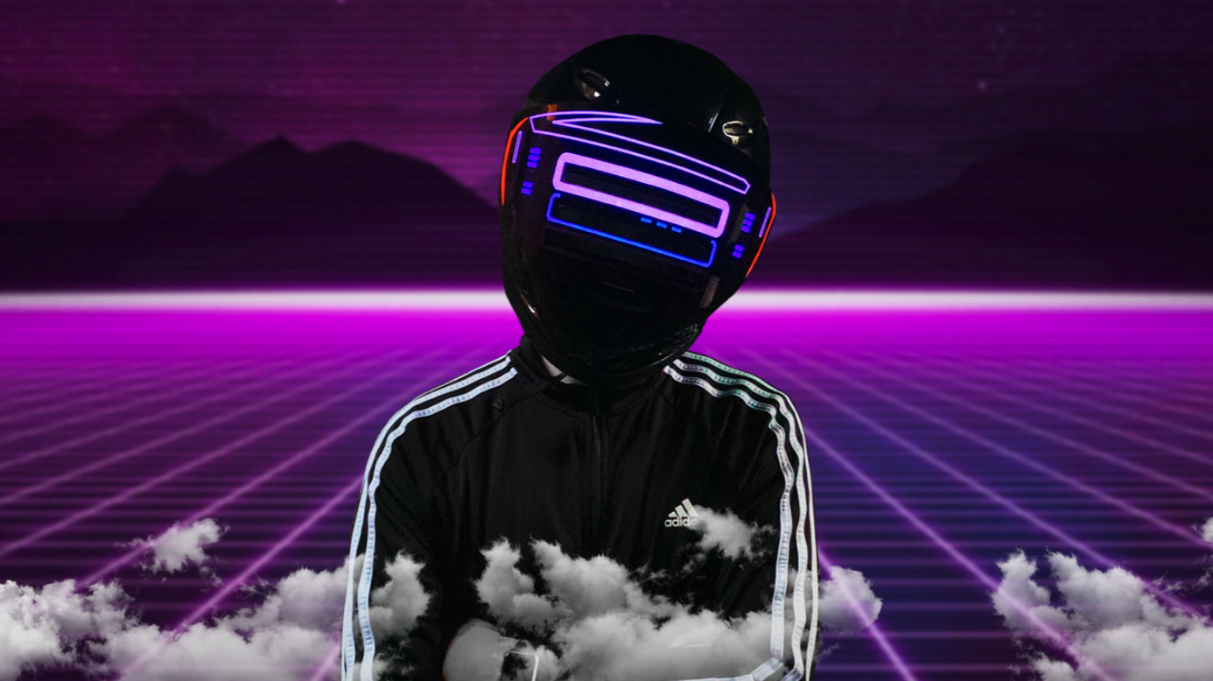
PRPL CHLD: ‘I got bored… and experimented with every musical instrument I could find’
But the DJ / Artist says he has 'a lot of respect' for the EDM scene - and is excited to change it.

PRPL CHLD has claimed that EDM “needs to be re-invented” – but also confesses that he’s listened to some form of EDM pretty much all his life.
Asked for his opinions on electronic acts such as Skrillex and Marshmello, PRPL CHLD said: “Yes, I have a lot of respect for artists who come out of a genre as saturated as EDM, and can create something that changes the genre. To be anonymous, and just focus on the music and the art... THAT’S MY GOAL. To break the cycle of how repetitive music has been, and create a new, interesting palette we can enjoy.”
“I’m a huge fan of dance music, hip hop, emo, pop... I’ve always been surrounded by all genres of music.” When asked if that was because of where he grew up, he replied ” “Yeah, probably!”
Growing up in Pittsburgh, Pennsylvania, PRPL CHLD says his first inspiration to make music was going to the Pittsburgh Steelers football games as a young child. “That feeling when it’s kick off, and they play that anthem to get everyone in the stadium pumped up… THAT’S what I am going for when I write an intro!”
PRPL CHLD spent most of 2019 going through surgeries and chemotherapy to treat a rare, unexpected cancer. About a month after he was cured, COVID - 19 struck. Stuck in the house for over a year, PRPL CHLD says, “I got bored, and started to experiment with any musical instrument I could find.”
PRPL CHLD’s long-awaited new single ‘Right Now’’, a dance-house anthem, just dropped on all platforms January 8th. Visit PRPLCHLD.COM and join for FREE to be notified about upcoming live-music streams and new music.
Seeing as cancer and COVID-19 couldn’t stop him, we can’t wait to see what PRPL CHLD comes up with in the studio next.
VISIT WWW.PRPLCHLD.COM FOR MORE INFO

